**Exercise: Merging two data sources**

**Introduction**

By now, you should understand the concept of data merging and its practical applications. During this week you’ve learned about the concepts of join types, what a join key is and where it can be used. Remember, joins are one of the most basic and important operations in Microsoft Power BI and generally in all database systems.

In this exercise, you’ll have the opportunity to apply your knowledge by using Power Query to join two data sources; explore the relationships between two tables and match the related data.

**Case study**

Adventure Works has data with details, such as **Sales Order ID,** **Order Date,** **Product Key,** **Quantity**, **Unit Price,** **Reseller Key**, **Product**, **Reseller** and some other fields are stored in separate tables. These tables have a relationship with the *Sales* table because of the relational data architecture.

As you have learned before, although this relational data structure provides data integrity, it only shows the key values. To list the other details of the related tables, you must merge tables with joins.

Your manager, Adio Quinn, has assigned a task to you to list the *Sales* data with the **Sales Order ID**, **Order Date**, **Product Name,** **Quantity** and **Unit Price** columns. To do this, you must merge the *Sales* and *Product* tables by creating a Power BI query that merges the data.

Adio sends you the two ***.xlsx***files containing the Adventure Works company sales data named *Sales.xlsx,* and product data named *Product.xlsx*. The data sets have a common column named **ProductKey**. You will use the common column and match the columns. You need to read data from the two tables.

1. This exercise aims to assist you in understanding how to combine data by merging data.
2. By the end of this exercise, you’ll understand how to merge data in Power Query, to explore the relationships between two tables and match the related data.

**Resources**

There are two resources for you to use in this exercise:

[Product](https://d3c33hcgiwev3.cloudfront.net/PStQfkFLQumiEv5P62OGiA_c02f4328492a46c9ad1a4159e94c19a1_Product.xlsx?Expires=1709856000&Signature=akZr5G92ySecHGslOKh63tGrTMP9so4RvjzU73o1ovx1RkR3YtK7TVOoAQkMuNxgGLbigf2qkXKSyNhDU-YDARV~EmSBeOJ6gYKSqBHaWG6aOsKcSj1NeQ0VP-V~Kh0f1c~YPPXTFi5ZbTs8O-VkslOHG8rPFJ2YqJu7yu9eAx0_&Key-Pair-Id=APKAJLTNE6QMUY6HBC5A" \t "_blank)

[XLSX File](https://d3c33hcgiwev3.cloudfront.net/PStQfkFLQumiEv5P62OGiA_c02f4328492a46c9ad1a4159e94c19a1_Product.xlsx?Expires=1709856000&Signature=akZr5G92ySecHGslOKh63tGrTMP9so4RvjzU73o1ovx1RkR3YtK7TVOoAQkMuNxgGLbigf2qkXKSyNhDU-YDARV~EmSBeOJ6gYKSqBHaWG6aOsKcSj1NeQ0VP-V~Kh0f1c~YPPXTFi5ZbTs8O-VkslOHG8rPFJ2YqJu7yu9eAx0_&Key-Pair-Id=APKAJLTNE6QMUY6HBC5A" \t "_blank)

[Sales](https://d3c33hcgiwev3.cloudfront.net/M9pLovLtTpKDada_DE40uw_47fb45076b5d4789b845ebf0bc723aa1_Sales.xlsx?Expires=1709856000&Signature=MAgHU8Oskm16x-0uECf5K0u8~~egIBKj5v1OIaacVFI6BMaJi5iSf5QOTU-0tB0fW-P6r4b8DP3FltuVWvhRspFcyRR-hZdjoNchUvki8tAgTaQzZosVjam7yZdotSar4LTRa4odAQJlLV2gZDfFVrDGcTtbVfENSiGckJZTfhg_&Key-Pair-Id=APKAJLTNE6QMUY6HBC5A" \t "_blank)

[XLSX File](https://d3c33hcgiwev3.cloudfront.net/M9pLovLtTpKDada_DE40uw_47fb45076b5d4789b845ebf0bc723aa1_Sales.xlsx?Expires=1709856000&Signature=MAgHU8Oskm16x-0uECf5K0u8~~egIBKj5v1OIaacVFI6BMaJi5iSf5QOTU-0tB0fW-P6r4b8DP3FltuVWvhRspFcyRR-hZdjoNchUvki8tAgTaQzZosVjam7yZdotSar4LTRa4odAQJlLV2gZDfFVrDGcTtbVfENSiGckJZTfhg_&Key-Pair-Id=APKAJLTNE6QMUY6HBC5A" \t "_blank)

**Instructions**

* Create a new Power BI project called *Exercise – Merging two tables*. Follow the prompts below to complete the exercise.

**Step 1: Download the Excel files**

* Download the *Sales.xlsx*and *Product.xlsx* files, which will be used in this exercise.

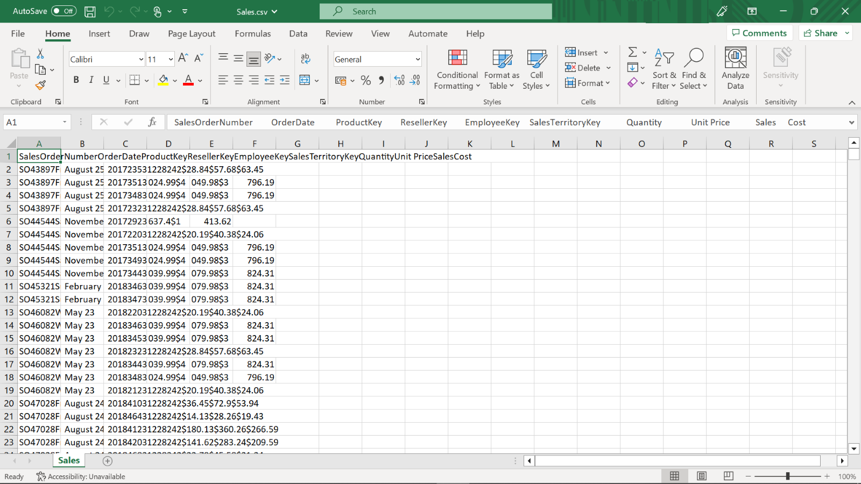

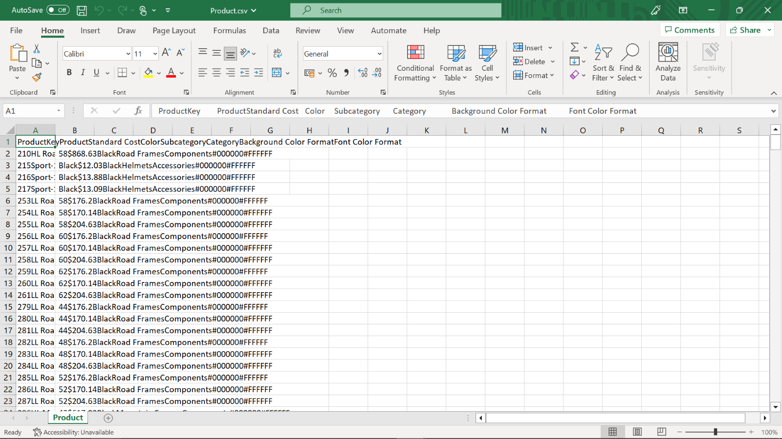

**Step 2: Create a Power BI project**

1. Create a Power BI project and open the Power Query editor.
2. Create a new Power BI project called *Exercise – Merging two tables*.

**Step 3: Open the Power Query Editor**

* Open the Power Query editor and import your datasets, *Sales* and *Product*.

**Step 4: Merge queries**

1. After selecting the *Sales* data in the **Queries** pane, select **Merge Queries**.
2. In the opened window, the *Sales* table will be shown automatically in the upper section of the window.
3. Choose the next table for merging, which is *Product*.
4. **ProductKey** is the common column between the tables, so click on the **ProductKey** columns in each table.
5. For the **Join Kind** dropdown, choose the join type **Left Outer Join**, which selects all records from the left table and matching records from the right table.

**Step 5: Select column(s) from Product**

1. After you merged the tables, a new column, named **Product** is added to the right side of the *Sales* data. This allows you to choose columns from the *Product* table.
2. Select the column named **Product** from the *Product* table.

**Step 6: Choose and reorder columns from Sales**

1. After you add the new column, **Product,** it is added to the *Sales* query as **Product.Product**. You must rename this column as **Product** to avoid confusion.
2. Move the **Product** field from right to left.
3. Remove the unwanted columns, **Product Key** (name of product is added by merge, so you will not need the key value of product), **Reseller Key**, **Employee Key** and **Sales Territory Key** columns.
4. Reorder the final list as indicated in your task to **Sales Order Number**, **Order Date**, **Product**, **Quantity** and **UnitPrice**.

**Conclusion**

You have successfully merged your datasets using Power Query by following these steps. The datasets are now joined and ready for further analysis in Power BI Desktop. As mentioned earlier, you can explore the relationships between two tables and match their related data by doing this operation.

**Exemplar: Merging two data sources**

**Overview**

In the exercise *Merging two data sources,* you put into practice your understanding of how to merge two data sources and by importing, merging and choosing join kind in Power Query.

Your objective in this exercise was to merge data sources by completing the following tasks:

* Download CSV Files
* Open *Power Query Editor*
* Choose Queries
* Merge Queries
* Select Column(s) from *Product*
* Choose and reorder columns from *Sales*

This reading provides a step-by-step guide for completing these tasks, accompanied by screenshots for comparison with your own copy.

**Step 1: Download CSV files**

* Download *Sales.csv* and *Product.csv*files.





**Step 2: Create a Power BI project**

1. Create a Power BI project and open the Power Query editor.
2. Create a new Power BI project called *Exercise – Merging two tables*.



**Step 3: Open the Power Query Editor**

Import your datasets, *Sales* and *Product*.

1. Select the **Text/CSV** option from **Get Data** menu, in the **Data** group when the **Home** ribbon tab is selected.
2. Select the *Sales.csv* file and then select **Transform Data** in the window that opened.

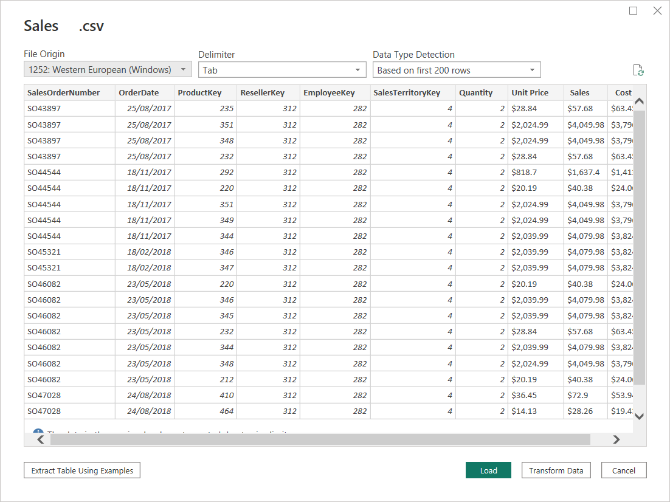

3. The Power Query Editorwindow opens. You can now select the queries that you want to merge.

4. In Power Query Editorwith the **Home** ribbon selected, select the **New Source** menu in the **New Query** group and choose **Text/CSV**.

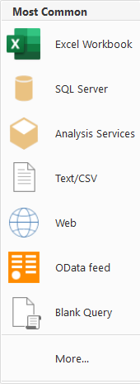

5. Select *Product.csv* and then select **OK**.

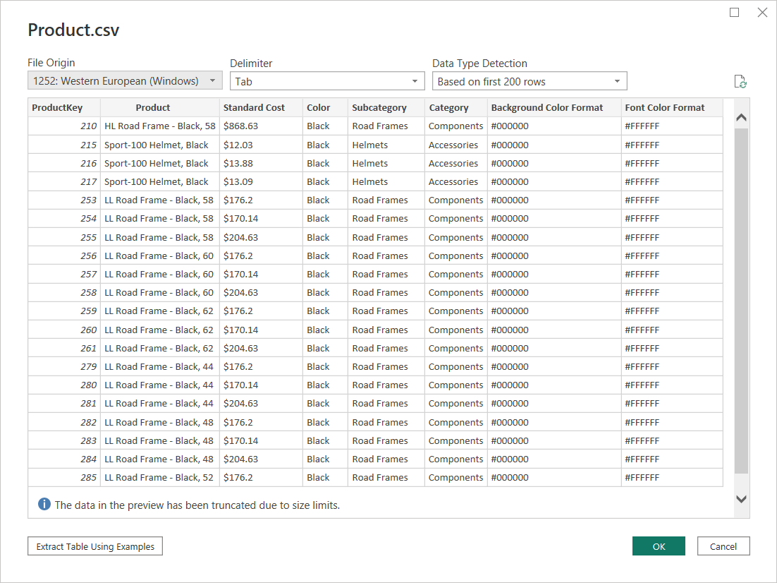

**Step 4: Merge queries**

Merge the *Sales* and *Product* queries, using **Left Outer Join** in the common column **ProductKey**.

1. After selecting the **Sales** data in the **Queries** pane, under the **Home** ribbon, click **Merge Queries** in the **Combine** group.



2. Choose **Merge Queries** inside the **Merge Queries** dropdown menu.



3. In the opened window, the *Sales* table will be automatically shown in the upper parts choose *Product* in the dropdown and click **ProductKey** columns in each table to mark the common column between the tables.

4. For the **Join Kind** dropdown, choose the **Left Outer Join** which selects all records from the left table and matching records from the right table.

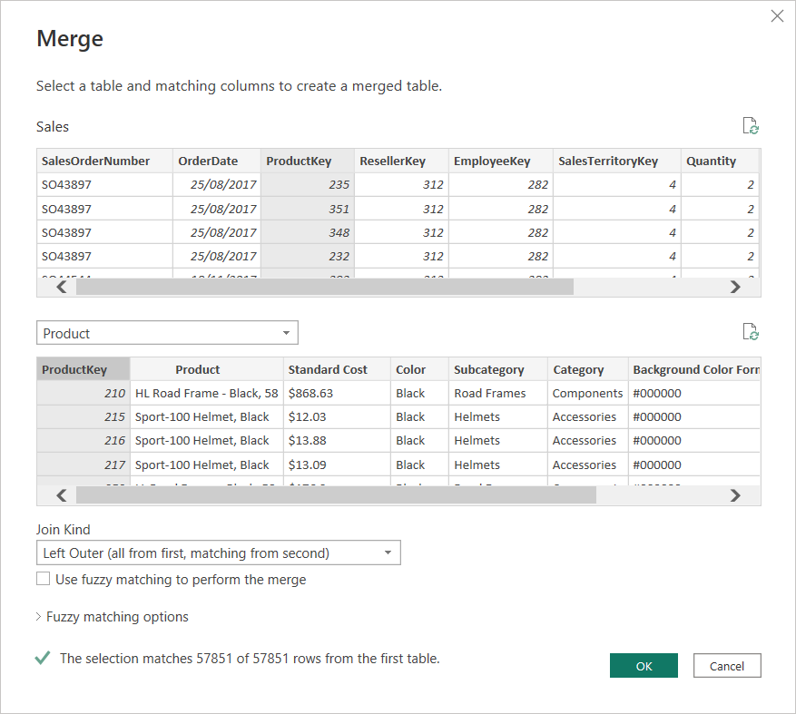

**Step 5: Select column(s) from Product**

After you merge the tables, a new column, named **Product,** is added to the right side of the *Sales* table, which allows you to choose columns from the *Product* table.

1. Find the column named **Product** at the most right of the table and click on the expand button to the right of the column.
2. Choose the **Product** column by clicking on it and deselecting any other columns. Note, the **Product** query and column have the same names, so make sure you don’t get confused.

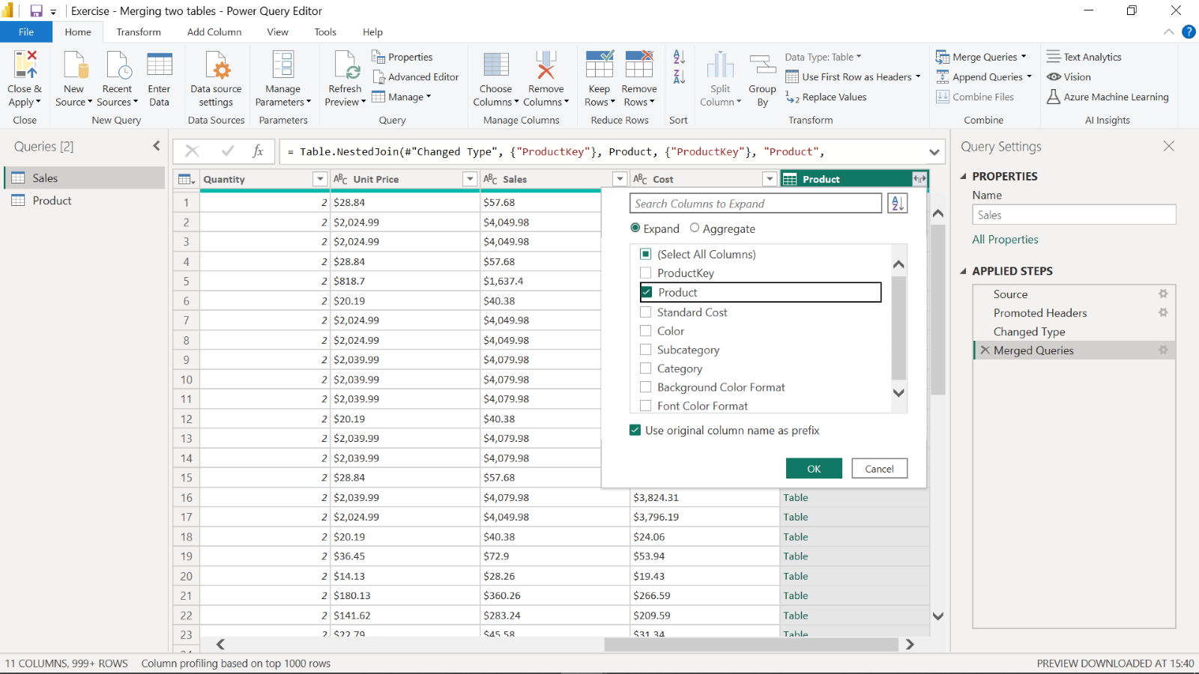

3. Rename **Product.Product** column to **Product.**

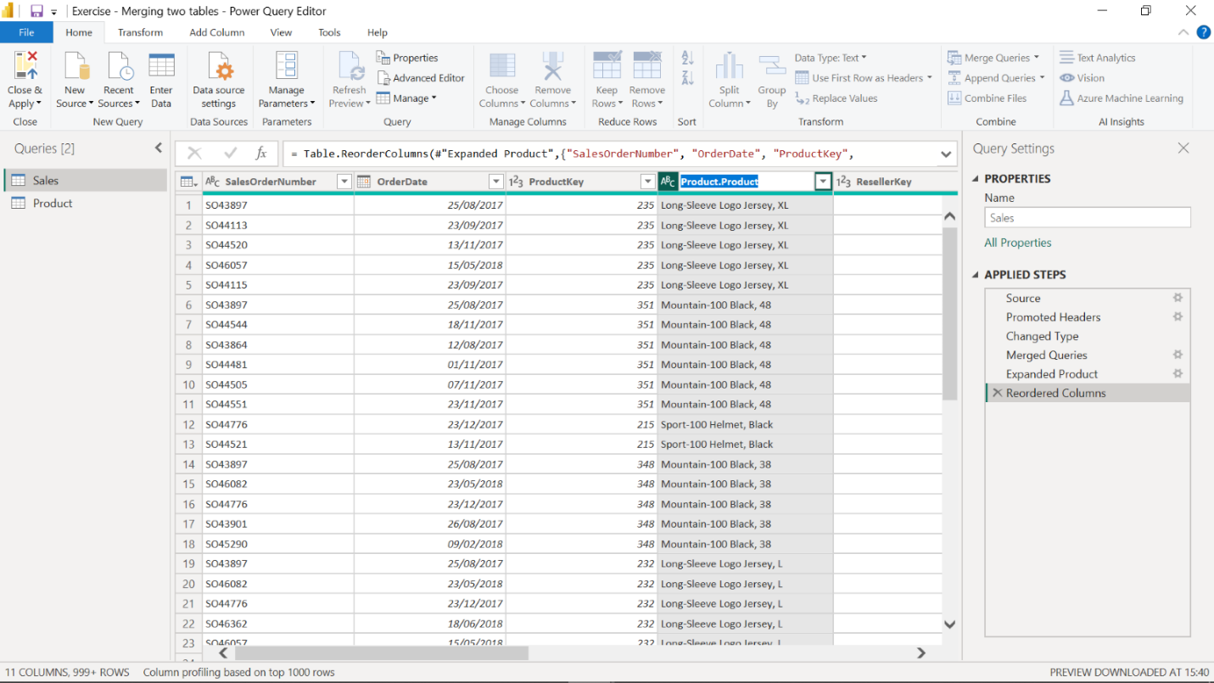

**Step 6: Choose and reorder columns from Sales**

Reorder the columns from the *Sales* table after merging them with *Product* table.

1. Your manager asked you to show the name of the product, so you won’t need the key anymore. Remove **ProductKey** column by right clicking on the column and select **Remove**.

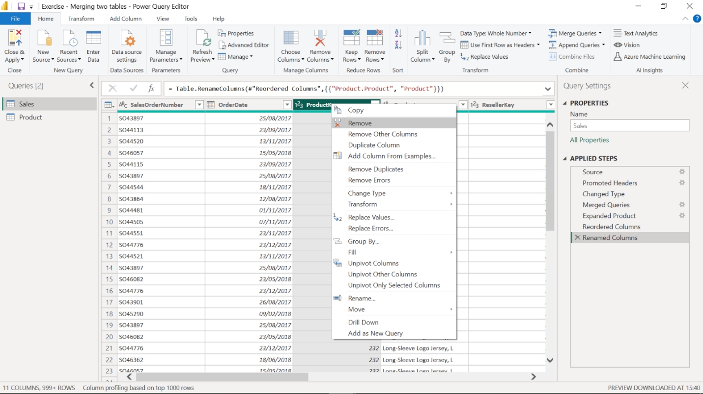

2. Move the newly added **Product** columnbetween **OrderDate** and **Quantity** columns by dragging and dropping them in place.

3. Remove **Reseller**, **Employee** and **Sales Territory Key** columns from the query.

4. Your final query will look like the image below after you have renamed, removed and reordered columns.

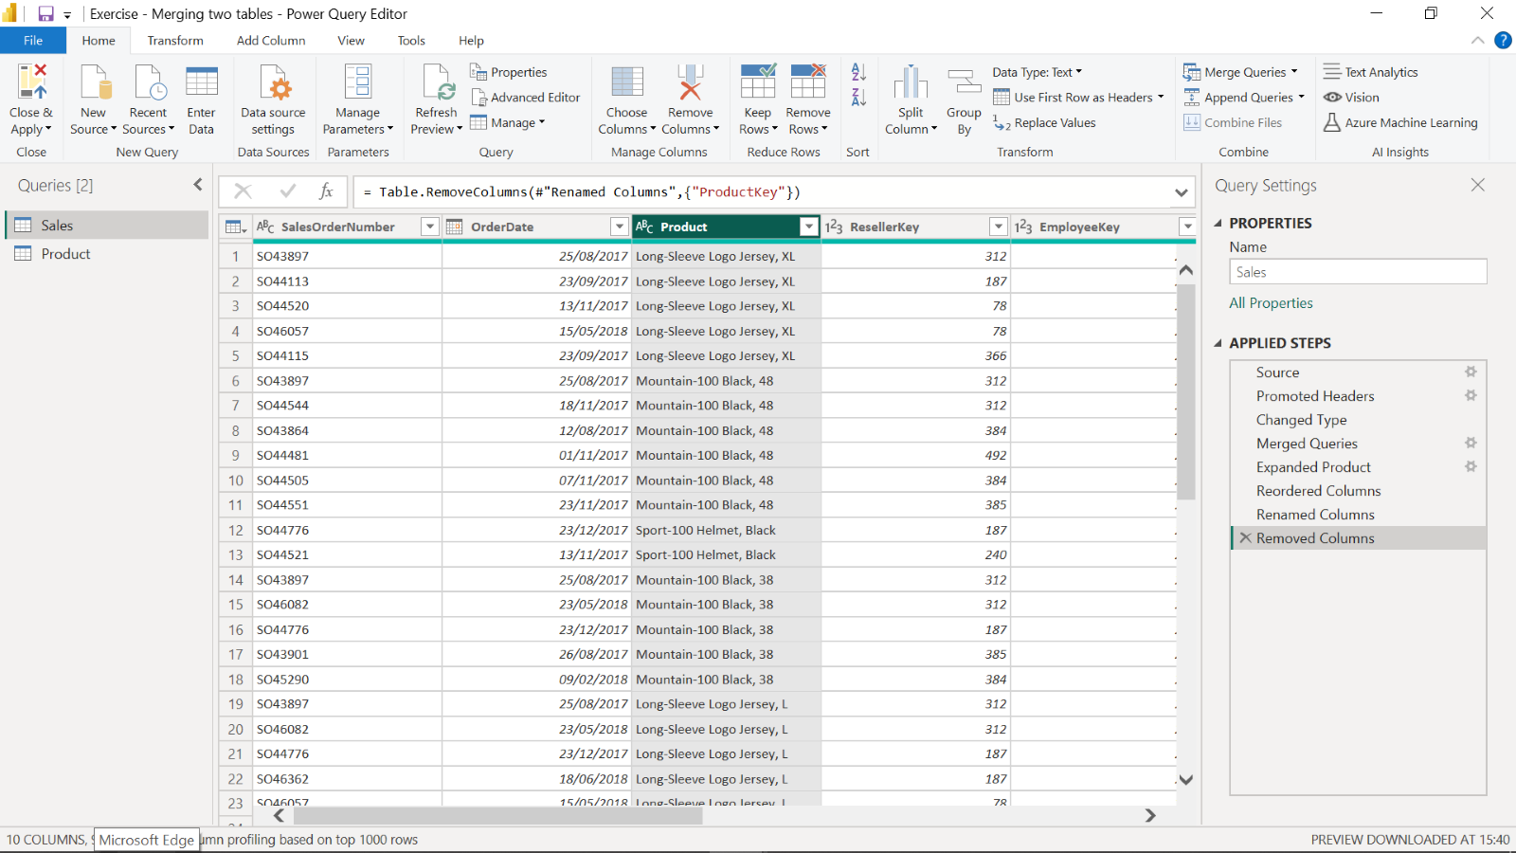

**Conclusion**

Your objective for this exercise was to apply techniques for importing, formatting, and merging data. In this context, you learned how to use Power Query Editor to import more than one data source, merge them by using the common columns, choose the columns from both tables and format the columns as needed.

You can refer to [*Combine multiple tables into a single table*](https://learn.microsoft.com/en-us/training/modules/clean-data-power-bi/5-combine-tables) article on the *Microsoft Learn* site to review more details on the merging data processes in Power BI.